Attempt 2

All questions

Top of Form

Question 1:

**Skipped**

**True or False: Tableau can create worksheet-specific filters**

* 

**True**

**(Correct)**

* 

**False**

**Explanation**

Yes, it is possible to create worksheet-specific filters in Tableau.

When you add a filter to a worksheet, by default it applies to the **current** worksheet. Sometimes, however, you might want to apply the filter to other worksheets in the workbook.

Then, you can select specific worksheets to apply the filter to or apply it globally to all worksheets that use the same data source or related data sources.

**Reference:**<https://help.tableau.com/current/pro/desktop/en-us/filtering_global.htm>

Bottom of Form

Top of Form

Question 2:

**Skipped**

**Which of the following are True for Measure Names?**

* 

**It contains all the measures in your data, collected into a single field with continuous values.**

* 

**When working with a text table showing Profit for each Category, when you add Sales to the text table (by dragging it and dropping it in the view), the measure names field is automatically dragged to the row and filter shelves.**

**(Correct)**

* 

**It contains the names of all measures in your data, collected into a single field with discrete values.**

**(Correct)**

* 

**When you add it to a view, all of the measure names appear as row or column headers in the view.**

**(Correct)**

**Explanation**

**It contains all the measures in your data, collected into a single field with continuous values -** This is the definition for 'Measure Values'.

All others are True w.r.t. Measure Names!

The **Measure Names** field contains the names of all measures in your data, collected into a single field with discrete values.

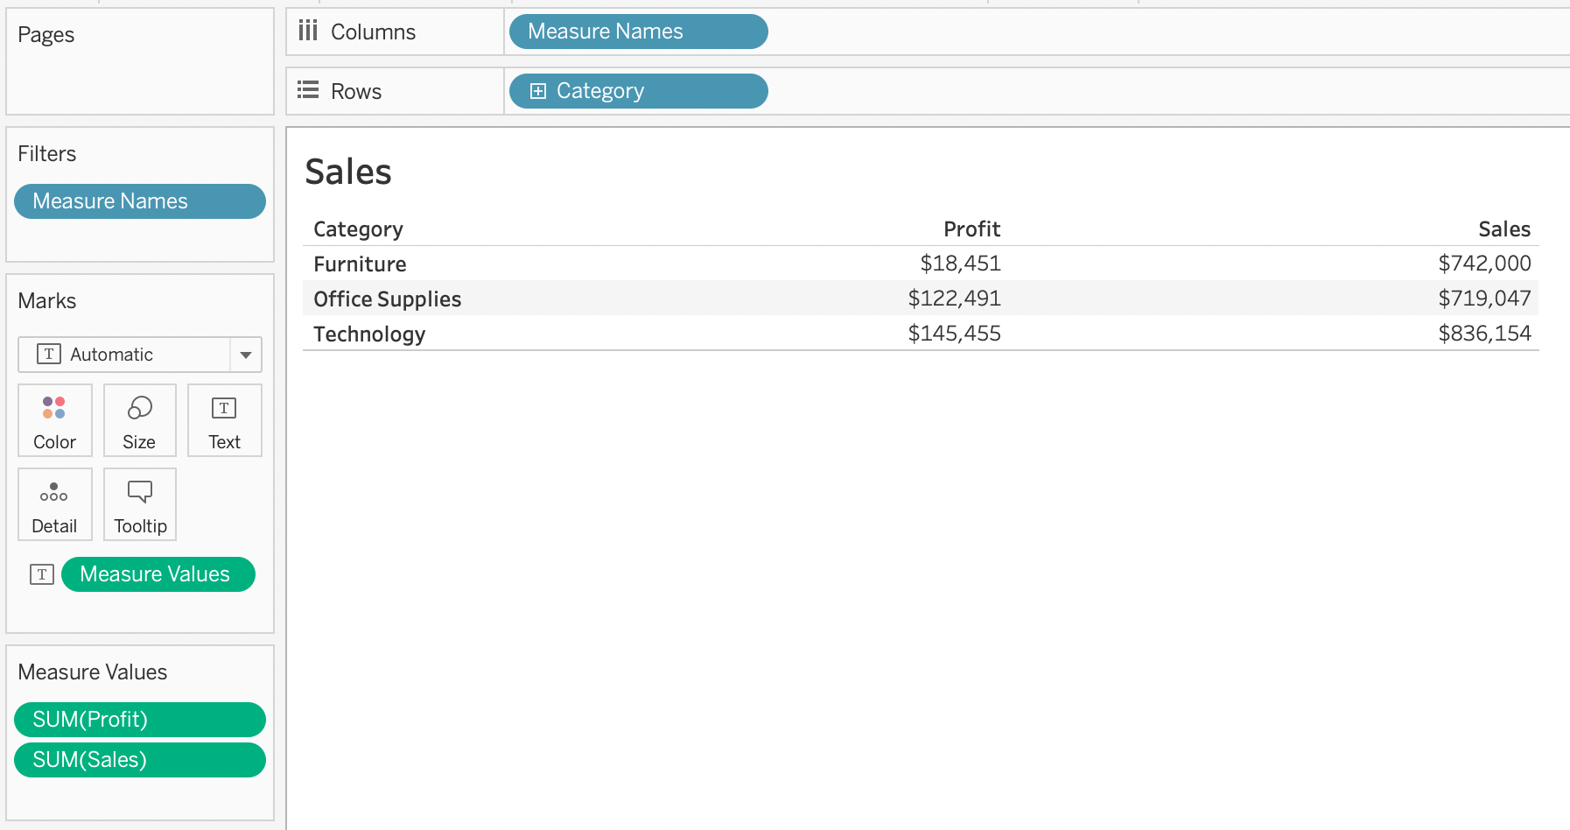

**Documentation :**<https://help.tableau.com/current/pro/desktop/en-us/datafields_understanddatawindow_meavalues.htm>

Bottom of Form

Top of Form

Question 3:

**Skipped**

**For creating variable sized bins we use __________________**

* 

**Sets**

* 

**Calculated Fields**

**(Correct)**

* 

**Table Calculations**

* 

**Groups**

**Explanation**

One way to view a measure in Tableau Desktop is to split it into bins. You can think of bins as **buckets** based on a range of values. For example, say you have a measure that represents age. Instead of aggregating the measure to calculate the average age, you can bin the measure to define age groups: 0–5, 6–10, 11–15, and so on. Then you can count the number of people in each age group.

**Create a calculated field for variable bin size**

**Step 1**

Select Analysis > Create Calculated Field.

**Step 2**

In the Calculated Field dialog box, complete the following steps:

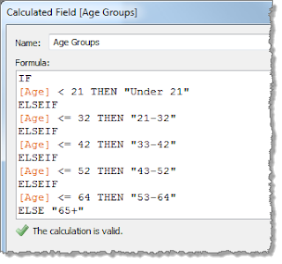

**Reference:**<https://riti-ritesh.blogspot.com/2016/07/creating-variable-sized-bins_8.html>

Bottom of Form

Top of Form

Question 4:

**Skipped**

**True or False: Context Filters are executed after Data Source filters**

* 

**False**

* 

**True**

**(Correct)**

**Explanation**

**THIS IS A VERY IMPORTANT QUESTION**

To answer this question, you need to understand Tableau's **Order of Operations.**See below and remember this always:

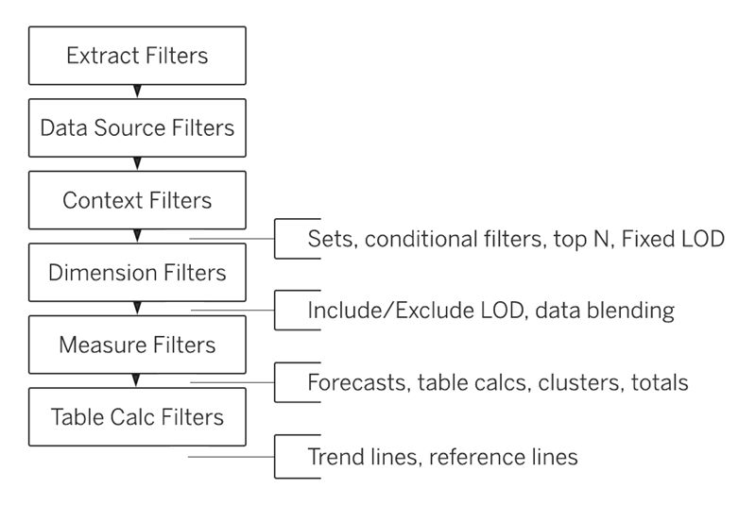

**Reference:**<https://help.tableau.com/current/pro/desktop/en-us/order_of_operations.htm>

Bottom of Form

Top of Form

Question 5:

**Skipped**

**True or False: A sheet cannot be used within a story directly. Either sheets should be used within a dashboard, or a dashboard should be used within a story.**

* 

**False**

**(Correct)**

* 

**True**

**Explanation**

It is possible in Tableau to use a sheet within a story directly.

Moreover, in Tableau, a **story** is a sequence of visualizations that work together to convey information. You can create stories to tell a data narrative, provide context, demonstrate how decisions relate to outcomes, or to simply make a compelling case.

**At the same time, a story is also a collection of sheets, arranged in a sequence. Each individual sheet in a story is called a story point.**

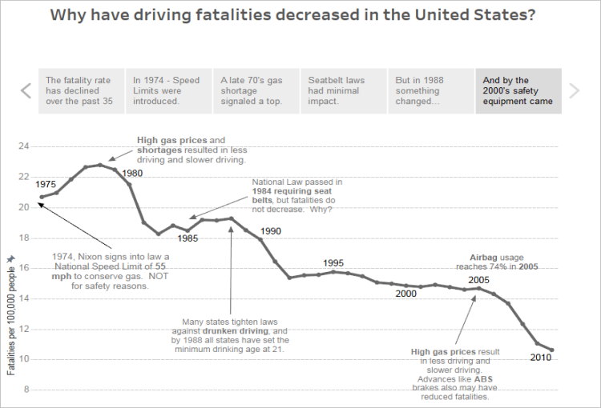For Example :



**Reference:**<https://help.tableau.com/current/pro/desktop/en-us/stories.htm>

Bottom of Form

Top of Form

Question 6:

**Skipped**

**Which of the following are interactive elements that can be added to a dashboard for users?**

* 

**Highlight Action**

**(Correct)**

* 

**Filter Action**

**(Correct)**

* 

**URL Action**

**(Correct)**

* 

**Edit Tooltip Action**

**Explanation**

We can perform filter, URL and highlight actions out of the above given choices on a dashboard. Please refer to the image below:

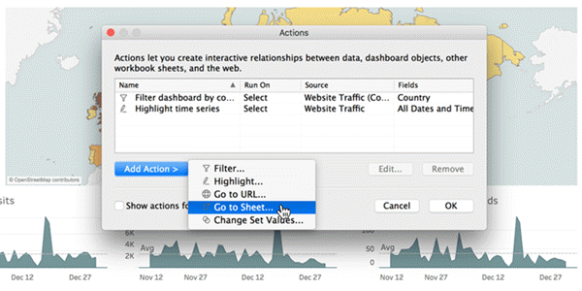

**Reference:**<https://help.tableau.com/current/pro/desktop/en-us/actions_dashboards.htm>

Bottom of Form

Top of Form

Question 7:

**Skipped**

**True or False: We can disaggregate the data, to see all of the marks in the view at the most detailed level of granularity**

* 

**True**

**(Correct)**

* 

**False**

**Explanation**

Whenever you add a measure to your view, an aggregation is applied to that measure by default. This default is controlled by the **Aggregate** Measures setting in the **Analysis** menu.

If you decide you want to see all of the marks in the view at the **most detailed** level of granularity, you can disaggregate the view. Disaggregating your data means that Tableau will display a **separate** mark for every data value in every row of your data source.

To disaggregate all measures in the view:

Clear the **Analysis >Aggregate** Measures option. If it is already selected, click Aggregate Measures once to deselect it.

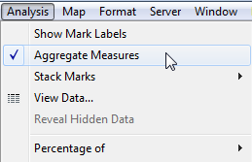

**Reference:**<https://help.tableau.com/current/pro/desktop/en-us/calculations_aggregation.htm>

Bottom of Form

Top of Form

Question 8:

**Skipped**

**True or False: It is possible to change the Geographic Role of a dimension**

* 

**False**

* 

**True**

**(Correct)**

**Explanation**

A geographic role associates each value in a field with a latitude and longitude value.

Assigning a geographic role based on the type of location (such as state versus postcode) helps ensure that your data is plotted correctly on your map view. For example, you can assign the City geographic role to a field that contains a list of city names.

**To assign a geographic role to a field:**

In the Data pane, click the data type icon next to the field, select Geographic Role, and then select the geographic role you want to assign to the field.

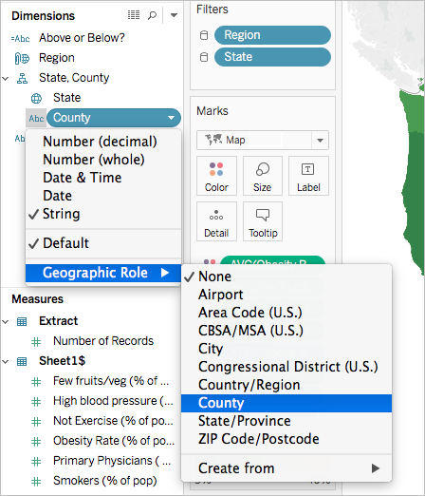

When you assign a geographic role to a field, Tableau adds two fields to the **Measures** area of the **Data** pane: Latitude (generated) and Longitude (generated).

These fields contain **latitude and longitude** values and are assigned the Latitude and Longitude geographic roles. If you double-click each of these fields, Tableau adds them to the Columns and Rows shelves and creates a map view using the Tableau background map.

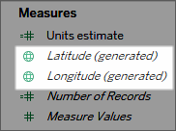

**Reference:**<https://help.tableau.com/current/pro/desktop/en-us/maps_geographicroles.htm>

Bottom of Form

Top of Form

Question 9:

**Skipped**

**Which of the following returns the Absolute Value of a given number?**

* 

**ZN(Number)**

* 

**ABS(Number)**

**(Correct)**

* 

**FLOOR(Number)**

* 

**CEILING(Number)**

**Explanation**

**From the official Tableau website:**

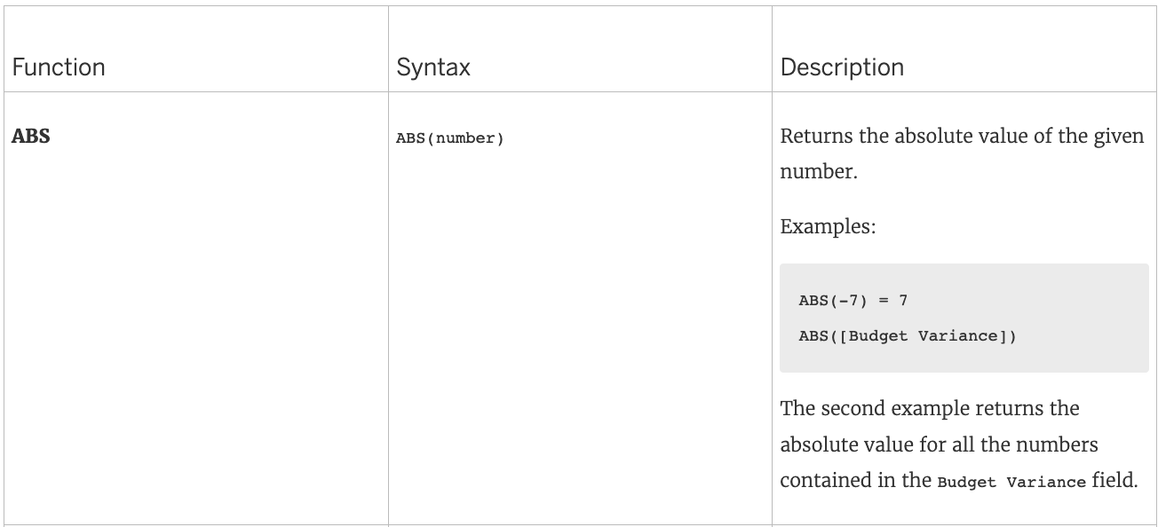

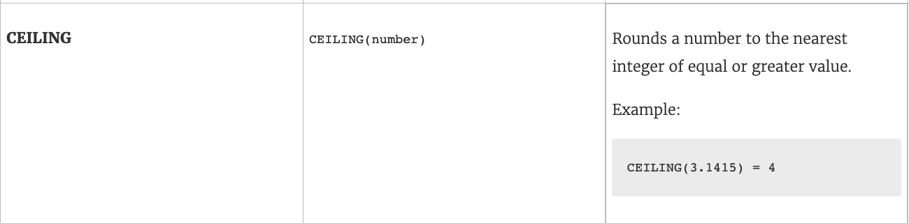

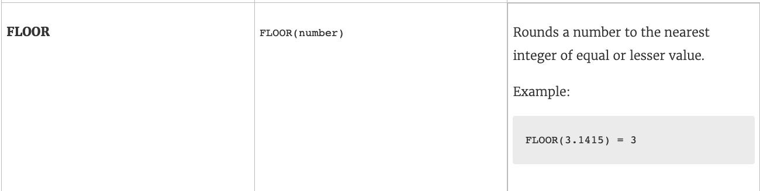

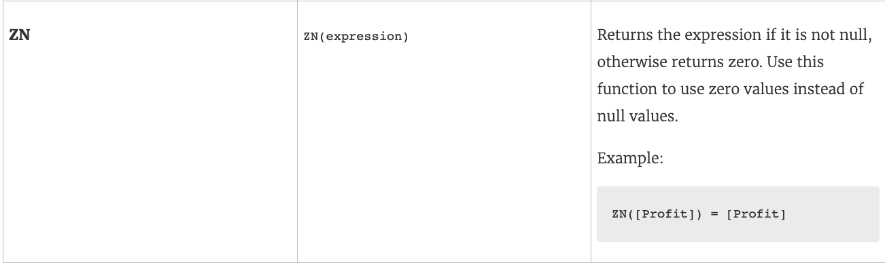

**Reference:**<https://help.tableau.com/current/pro/desktop/en-us/functions_functions_number.htm>

Bottom of Form

Top of Form

Question 10:

**Skipped**

**Which of the following is not a Trend Line Model?**

* 

**Logarithmic Trend Line**

* 

**Binomial Trend Line**

**(Correct)**

* 

**Linear Trend Line**

* 

**Exponential Trend Line**

**Explanation**

According to the official Tableau documentation, there are 5 types of trend lines which we can work with in Tableau :

1) Linear Trend Line

2) Logarithmic Trend Line

3) Exponential Trend Line

4) Polynomial Trend Line

5) Power Model

Hence, the correct answer is BINOMIAL trend line which is not present in Tableau.

See the following image:

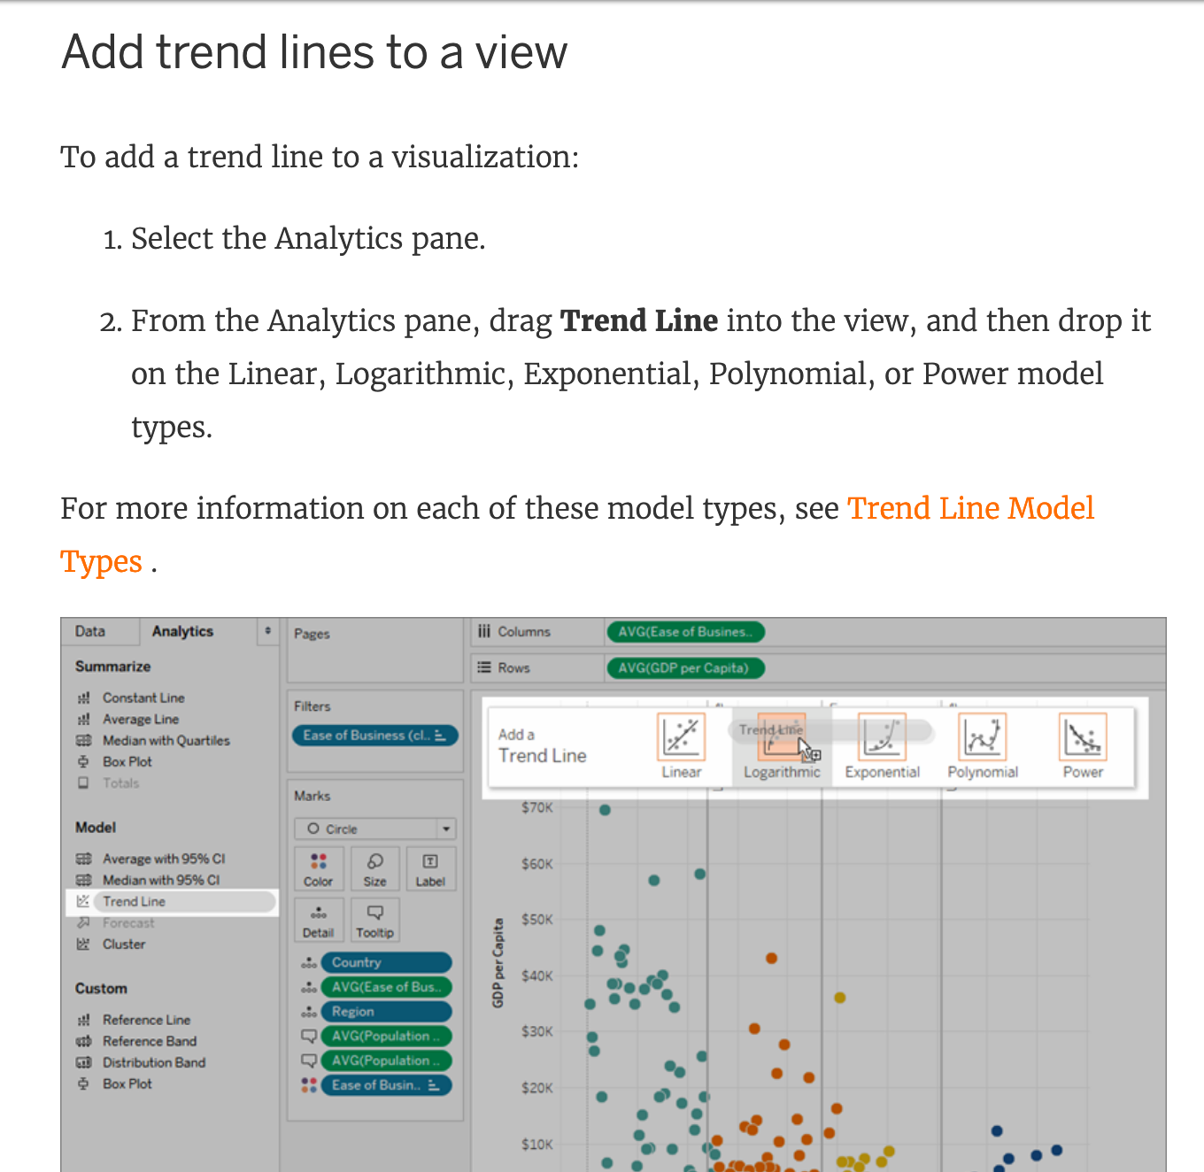

**For more information, refer to:** <https://help.tableau.com/current/pro/desktop/en-us/trendlines_add.htm>

Bottom of Form

Top of Form

Question 11:

**Skipped**

**The icon associated with the field that has been grouped is a ______________**

* 

**Globe**

* 

**Intersection**

* 

**=#**

* 

**Paper Clip**

**(Correct)**

**Explanation**

You can create a group to combine related members in a field. The icon associated with a group is a **paper clip**!



Bottom of Form

Top of Form

Question 12:

**Skipped**

**You can use the __________________ in Tableau to clean / organise your data.**

* 

**Data manager**

* 

**Data interpreter**

**(Correct)**

* 

**Data cleaner**

* 

**Data organiser**

**Explanation**

When you track data in Excel spreadsheets, you create them with the **human interface** in mind. To make your spreadsheets easy to read, you might include things like titles, stacked headers, notes, maybe empty rows and columns to add white space, and you probably have multiple tabs of data too.

When you want to analyze this data in Tableau, these aesthetically pleasing attributes make it **very difficult** for Tableau to interpret your data. That’s where **Data Interpreter**can help.

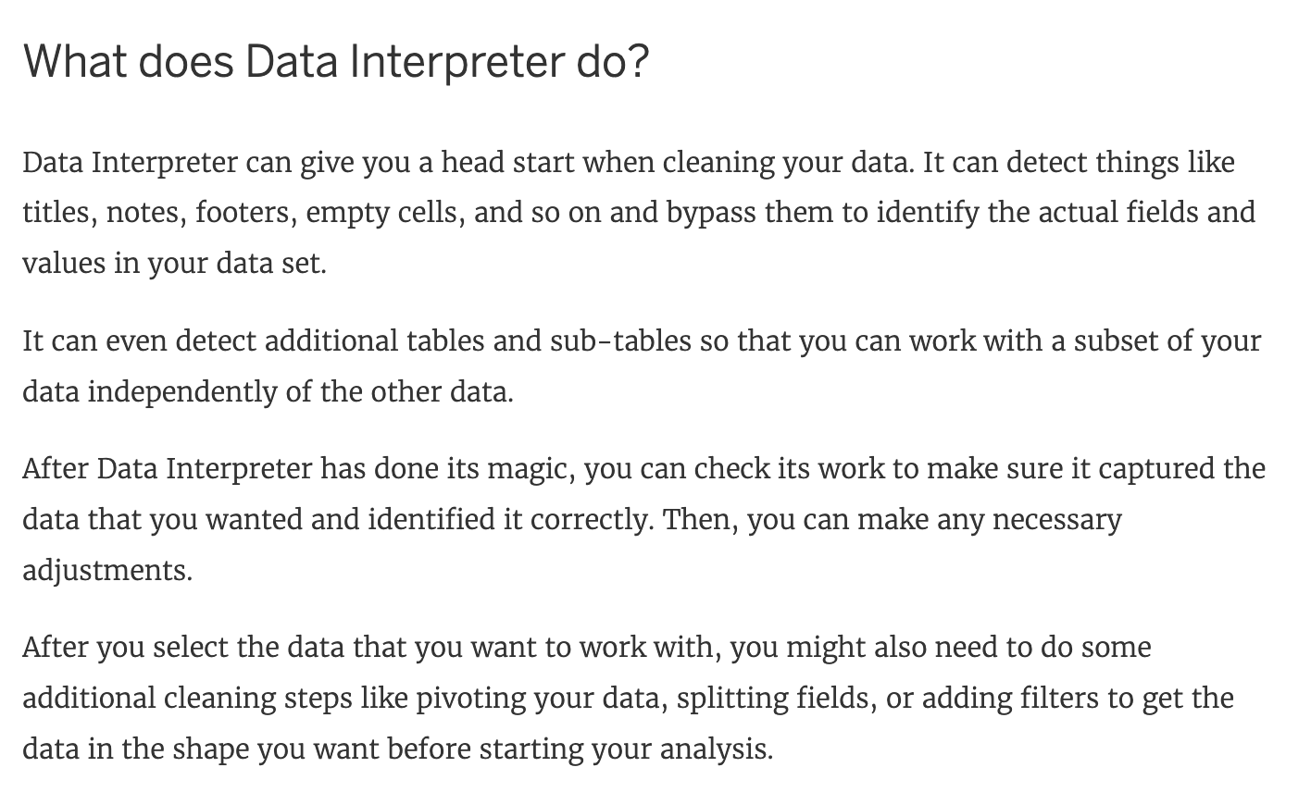

**Reference:** <https://help.tableau.com/current/pro/desktop/en-us/data_interpreter.htm>

Bottom of Form

Top of Form

Question 13:

**Skipped**

**Which of the following are the options to export the data used to build the view / visualisations?**

* 

**JSON format**

* 

**PDF File**

* 

**CSV file**

**(Correct)**

* 

**MS Access Database**

**(Correct)**

**Explanation**

You can export the data in a Tableau data source, including all or part of the records from your original data. Alternatively, you can export only the portion of data used to generate the view.

**Since the question mentions the data used to build the view, we'll focus on that :**

**\*Export data in the view to Microsoft Access or .csv\***

Export the data that is used to generate the view as an Access database (Windows only) or .csv file (Mac only).

1) In Tableau Desktop, select Worksheet > Export > Data.

2) Select a location and type a name for your Access database or .csv file.

3) Click Save.

4) If you're on Windows, the Export Data to Access dialog box displays to give you the option to immediately use the new Access database and continue working in Access without interrupting your work flow.

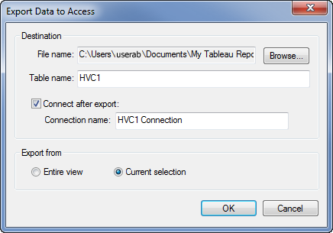

**Reference:**<https://help.tableau.com/current/pro/desktop/en-us/save_export_data.htm>

Bottom of Form

Top of Form

Question 14:

**Skipped**

**When using a Blend, what is the color of tick-mark on the primary and secondary data sources respectively?**

* 

**Red, Blue**

* 

**Blue, Red**

* 

**Blue, Orange**

**(Correct)**

* 

**Orange, Blue**

**Explanation**

When using a Blend, the primary data source appears with a BLUE tick-mark and the secondary data source appears with a ORANGE tick-mark.

See below:

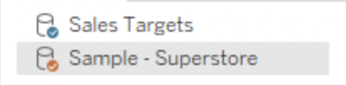

**Reference:**<https://help.tableau.com/current/pro/desktop/en-us/multiple_connections.htm>

Bottom of Form

Top of Form

Question 15:

**Skipped**

**To customize links based on the data in your dashboard, you can automatically enter field values as _______________ in URLs.**

* 

**parameters**

**(Correct)**

* 

**values**

* 

**inputs**

* 

**sets**

**Explanation**

A URL action is a hyperlink that points to a web page, file, or other web-based resource outside of Tableau. You can use URL actions to create an email or link to additional information about your data. To customize links based on your data, you can automatically enter field values as **parameters** in URLs.

**Read more in depth at :**<https://help.tableau.com/current/pro/desktop/en-us/actions_url.htm>

Bottom of Form

Top of Form

Question 16:

**Skipped**

**We can use ______________ as a static tool to open and interact with packaged workbooks with extracted data sources that have been created in Tableau Desktop.**

* 

**Tableau Desktop**

* 

**Tableau Online**

* 

**Tableau Server**

* 

**Tableau Reader**

**(Correct)**

**Explanation**

The word 'static tool' gives it away.

**According to the official website :**

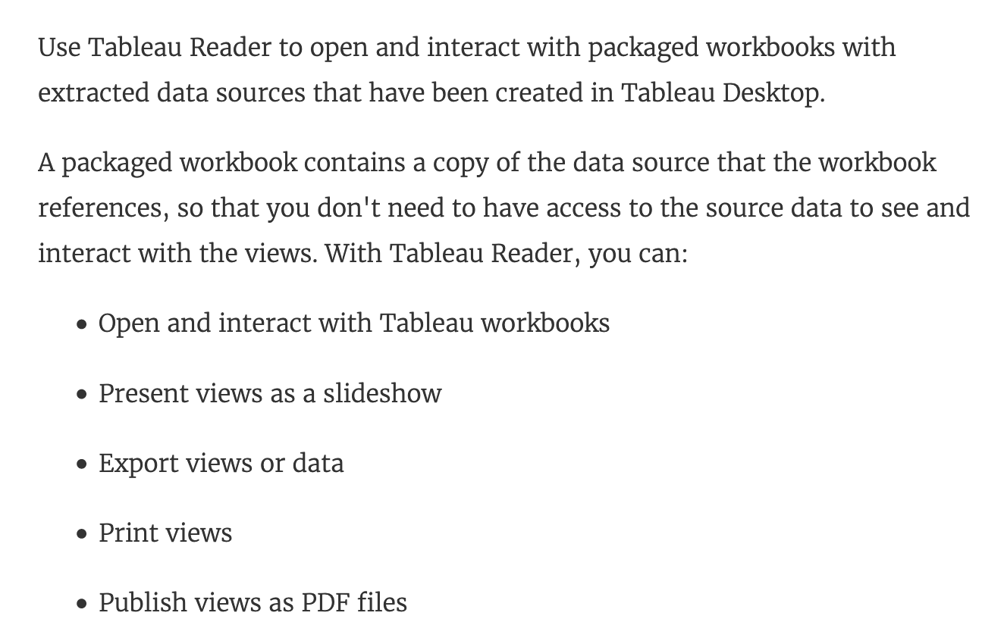

**Reference:**<https://help.tableau.com/current/reader/desktop/en-us/reader_welcome.htm>

Bottom of Form

Top of Form

Question 17:

**Skipped**

**True or False: Enabling any other type of sort (Field, alphabetic, or Nested) clears the manual sort we create.**

* 

**False**

* 

**True**

**(Correct)**

**Explanation**

This is true. a **Manual** **Sort** lets you select a value and move it to the desired position, either by dragging it in the list or using the arrows to the right.

However, as soon as you choose some other type of sort - be it field, nested, or alphabetic, our custom created manual sort gets deleted/cleared.

**Reference:** <https://help.tableau.com/current/pro/desktop/en-us/sortgroup_sorting_computed_howto.htm>

Bottom of Form

Top of Form

Question 18:

**Skipped**

**__________  is a technique in Tableau which will identify marks with similar characteristics**

* 

**Union**

* 

**Grouping**

* 

**Clustering**

**(Correct)**

* 

**Sets**

**Explanation**

Cluster analysis partitions marks in the view into clusters, where the marks within each cluster are more similar to one another than they are to marks in other clusters.

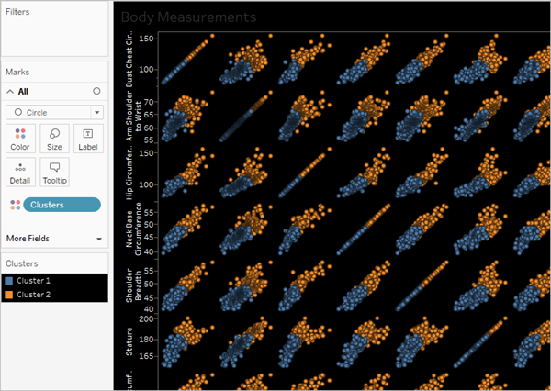

**Reference:** <https://help.tableau.com/current/pro/desktop/en-us/clustering.htm>

Bottom of Form

Top of Form

Question 19:

**Skipped**

**What does the box in a box plot represent?**

* 

**Minimum value of the data**

* 

**The median of the middle half of the data points**

* 

**Maximum value of the data**

* 

**The interquartile range**

**(Correct)**

**Explanation**

**In a box and whisker plot:**

1) The ends of the box are the upper and lower quartiles, so the box spans the [interquartile range](https://www150.statcan.gc.ca/n1/edu/power-pouvoir/glossary-glossaire/5214842-eng.htm#interquartile)

2) The median is marked by a vertical line inside the box

3) The whiskers are the two lines outside the box that extend to the highest and lowest observations.

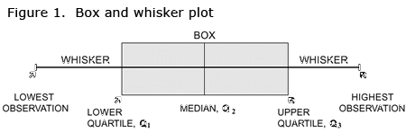

Bottom of Form

Top of Form

Question 20:

**Skipped**

**Which of the following is the correct way to calculate Profit Ratio in Tableau?**

* 

**SUM([Sales])/SUM([Profit])**

* 

**[Profit] / [Sales]**

* 

**SUM([Profit]) / SUM([Sales])**

**(Correct)**

* 

**[Sales] / [Profit]**

**Explanation**

**THIS IS A VERY IMPORTANT QUESTION**

Aggregation is an important concept to consider when creating calculated fields. A calculated field for SUM([Profit]) / SUM([Sales]) will give you a very different answer than [Profit] / [Sales], even though both formulas are valid.

If you do not provide the aggregation within the calculated field, Tableau will calculate the equation for **every record ( row )** in your analysis, then aggregate the answers for all of the rows together when the calculated field is added to the view.

In simple terms, if specify the aggregation such as SUM, what Tableau will do is that it will first calculate the sum of the Profit column ( say x ), then calculate the sum of the Sales column ( say y ), and then simply apply x/y ---> This is what we expect! Perfect!

BUT, if you don't specify the aggregation, it will go to **every single ROW**, perform Profit / Sales, and then aggregate the answers calculated for each row. This is simply NOT what we wan't!

**An example:**

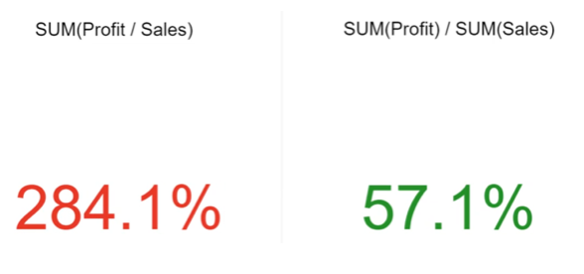

**Reference:** <https://www.linkedin.com/pulse/tableau-tip-dont-make-error-ratio-calculations-bob-newstadt>

Bottom of Form

Top of Form

Question 21:

**Skipped**

**A field that shows average home values for the European Union in 2016 is most likely :**

* 

**An aggregated measure**

**(Correct)**

* 

**A continuous date value dimension**

* 

**A geographical dimension**

* 

**A discrete date part dimension**

**Explanation**

This question type is directly from the Official Tableau Desktop Specialist exam guide.

Since we are talking about the **AVERAGE** home values for the United States in 2016, the question is directly offering us a hint that the answer has something to do with **aggregation** and that too the values tell us that we're working with **MEASURES**.

Date part and Date values don't really make much sense given the question, and neither does geography.

Therefore, the answer naturally is "An aggregated measure".

Bottom of Form

Top of Form

Question 22:

**Skipped**

**A Tableau Support case can be opened in which of the following valid ways?**

* 

**Contacting Salesforce using their website**

* 

**Using the Tableau learn website**

* 

**Using the support option on the Tableau website**

**(Correct)**

* 

**Using the Developer Community Forum**

**Explanation**

**It is possible to open a Tableau support case by visiting the following link :** <https://www.tableau.com/support/case>

Bottom of Form

Top of Form

Question 23:

**Skipped**

**Which data type in Tableau does this icon represent?**



* 

**Boolean**

**(Correct)**

* 

**True or False**

* 

**Geographic**

* 

**String**

**Explanation**

The following is the table for the data types in Tableau along with their icons:

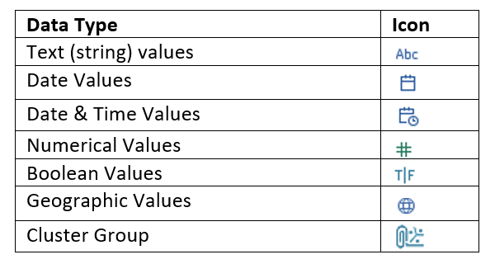

**Reference:** <https://help.tableau.com/current/pro/desktop/en-us/datafields_typesandroles_datatypes.htm>

Bottom of Form

Top of Form

Question 24:

**Skipped**

**True or False: To concatenate fields, they must be of same data type**

* 

**False**

* 

**True**

**(Correct)**

**Explanation**

Yes! To concatenate fields, they must be of same data type. However, there is a workaround which we can use - **Type casting**. See below:

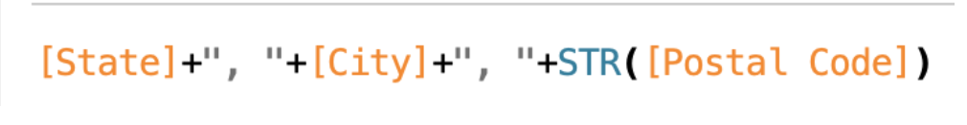

Here, State and City are Strings, but Postal Code? Nope. It's an Integer. So we can simply use the **STR() function** to convert it into a String, and hence the entire equation becomes valid!

Bottom of Form

Top of Form

Question 25:

**Skipped**

**True or False: A LEFT JOIN or INNER JOIN creates a row each time the join criteria is satisfied, which can result in duplicate rows. One way to avoid this is to use relationships instead.**

* 

**True**

**(Correct)**

* 

**False**

**Explanation**

**Joins** are used to combine data or rows from two or more tables based on a common field between them. This can cause data loss or duplication if tables are at different levels of detail, and joined data sources must be fixed before analysis can begin.

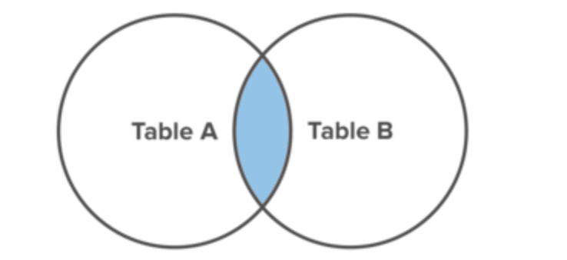Inner join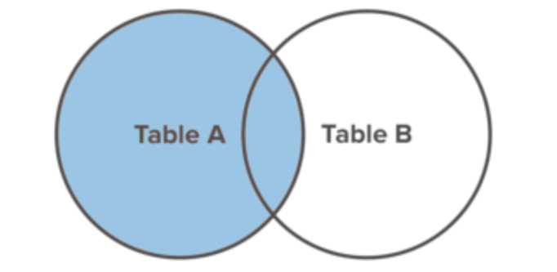     Left Join

While joins can filter data, **relationships** always preserve all measures. Now important values like money can never go missing. And unlike joins, relationships won’t double your trouble by duplicating data stored at different levels of detail.

**Reference:**<https://www.tableau.com/about/blog/2020/5/relationships-part-1-meet-new-tableau-data-model>

Bottom of Form

Top of Form

Question 26:

**Skipped**

**Which of the following are valid ways to trigger actions for a Dashboard?**

* 

**Double click**

* 

**Click**

* 

**Hover**

**(Correct)**

* 

**Menu**

**(Correct)**

* 

**Select**

**(Correct)**

**Explanation**

Whenever we want to add actions to a Dashboard, we can trigger then in the following 3 ways:

1) Select

2) Hover

3) Menu

Hover is best for **highlighting**, select for **filtering**. Menu action is added to the tooltip and user can decide whether to run that action or not (**best for URL actions**)

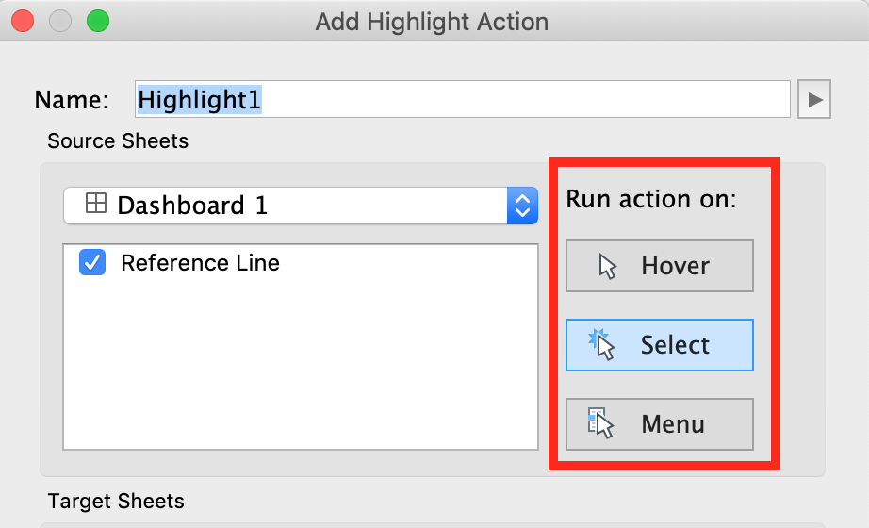

**Reference:**<https://help.tableau.com/current/pro/desktop/en-us/actions_dashboards.htm>

Bottom of Form

Top of Form

Question 27:

**Skipped**

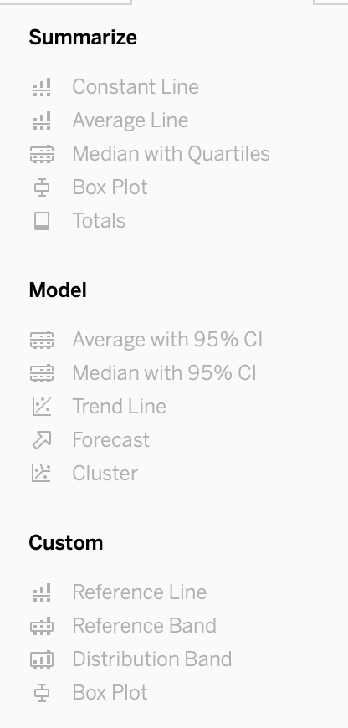

**What is this entire view referred to as in Tableau?**

* 

**Distribution Pane**

* 

**Summary Pane**

* 

**Data pane**

* 

**Analytics Pane**

**(Correct)**

**Explanation**

This is the**Analytics pane!** Read more from the official documentation below:

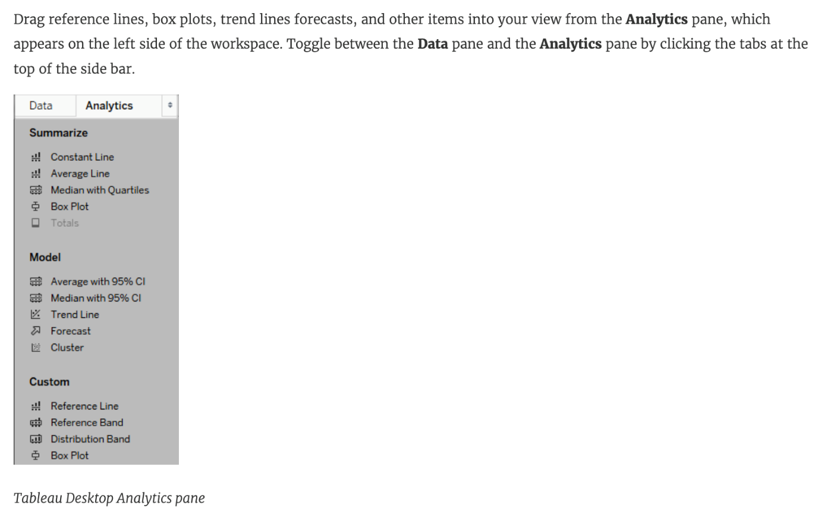

**Reference:** <https://help.tableau.com/current/pro/desktop/en-us/environ_workspace_analytics_pane.htm>

Bottom of Form

Top of Form

Question 28:

**Skipped**

**True or False: LEFT JOIN returns all rows from the left table, with the matching rows in the right table**

* 

**True**

**(Correct)**

* 

**False**

**Explanation**

This is **true**, indeed!

The **LEFT JOIN** keyword returns all records from the left table (table1), and the matched records from the right table (table2). The result is **NULL** from the right side, if there is no match.

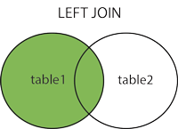

**Reference:**<https://www.w3schools.com/sql/sql_join_left.asp>

Bottom of Form

Top of Form

Question 29:

**Skipped**

**_____________ is a snapshot of the data that Tableau stores locally. Good for very large datasets of which we only need few fields.**

* 

**Tableau Packaged Workbook (.twbx)**

* 

**Tableau Data Extract (.tde)**

**(Correct)**

* 

**Tableau Workbook (.twb)**

* 

**Tableau Data Source (.tds)**

**Explanation**

**Tableau Data Extract (TDE)** is a snapshot of the data that Tableau stores locally. Good for very large datasets of which we only need few fields. Performance is optimised because it queries its own database engine instead of the local data source.

When you create an extract of your data, you can reduce the total amount of data by using **filters** and configuring other limits. After you create an extract, you can refresh it with data from the original data. When **refreshing** the data, you have the option to either do a full refresh, which replaces all of the contents in the extract, or you can do an incremental refresh, which only adds rows that are new since the previous refresh.

Extracts are **advantageous** for several reasons:

**1) Supports large data sets:** You can create extracts that contain billions of rows of data.

**2) Fast to create:** If you're working with large data sets, creating and working with extracts can be faster than working with the original data.

**3) Help improve performance:** When you interact with views that use extract data sources, you generally experience better performance than when interacting with views based on connections to the original data.

**4) Support additional functionality:** Extracts allow you to take advantage of Tableau functionality that's not available or supported by the original data, such as the ability to compute Count Distinct.

**5) Provide offline access to your data:** Extracts allow you to save and work with the data locally when the original data is not available. For example, when you are traveling.

Bottom of Form

Top of Form

Question 30:

**Skipped**

**What does it imply if a field has a blue background?**

* 

**It is a dimension**

* 

**It is discrete**

**(Correct)**

* 

**It is continuous**

* 

**It is a measure**

**Explanation**

When you connect to a new data source, Tableau assigns each field in the data source as **dimension or measure** in the Data pane, depending on the type of data the field contains. You use these fields to build views of your data.

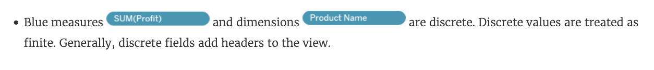

**Reference:** <https://help.tableau.com/current/pro/desktop/en-us/datafields_typesandroles.htm>

Bottom of Form

Top of Form

Question 31:

**Skipped**

**Which of the following charts types always includes bars sorted in descending order?**

* 

**Gantt chart**

* 

**Pareto Chart**

**(Correct)**

* 

**Stacked Bar Chart**

* 

**Pie Chart**

**Explanation**

A Pareto chart is a type of chart that contains both bars and a line graph, where individual values are represented in descending order by bars, and the ascending cumulative total is represented by the line.

On the primary axis, bars are used to show the raw quantities for each dimension member, sorted in descending order.

On the secondary axis, a line graph is used to show the cumulative total in percent format.

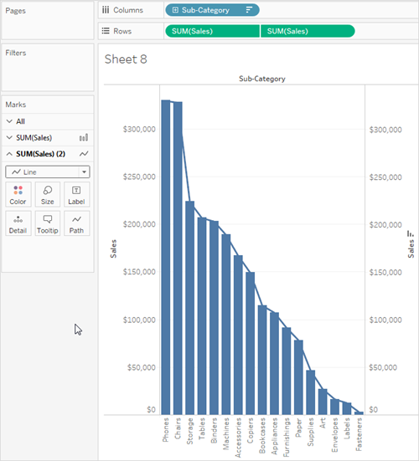

**Reference:**<https://help.tableau.com/current/pro/desktop/en-us/pareto.htm>

Bottom of Form

Top of Form

Question 32:

**Skipped**

**To use a quick table calculation, which of the following programming languages do you need to know?**

* 

**Java**

* 

**None of these**

**(Correct)**

* 

**Python**

* 

**Javascript**

**Explanation**

You don't need to know ANY programming language to use quick table calculations!

Follow along with the steps below to learn how to apply a quick table calculation to a visualization:

1) Open Tableau Desktop and connect to the **Sample-Superstore** data source, which comes with Tableau.

2) Navigate to a new worksheet.

3) From the **Data** pane, under Dimensions, drag Order Date to the Columns shelf.

4) From the **Data** pane, under Dimensions, drag State to the Rows shelf.

5) From the **Data** pane, under Measures, drag Sales to Text on the Marks Card.

6) From the **Data** pane, under Measures, drag Profit to Color on the Marks Card.

7) On the Marks card, click the Mark Type drop-down and select Square.

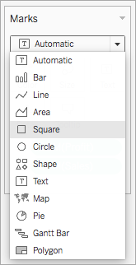

**The visualization updates to look like this:**

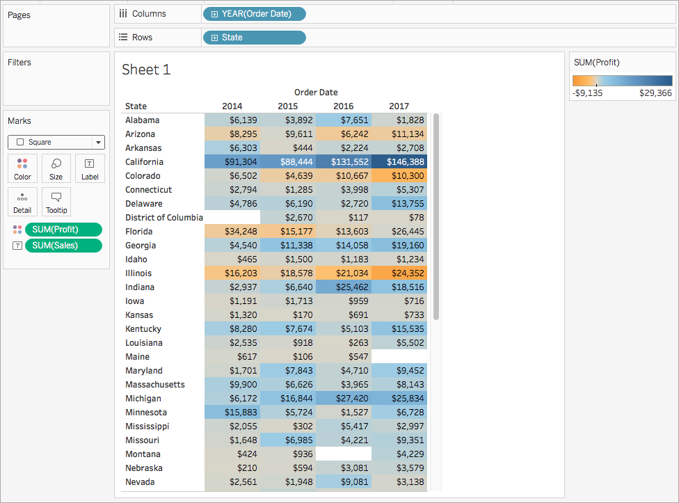

**Apply the quick table calculation**

1) On the Marks card, right-click SUM(Profit) and select Quick Table Calculation > Moving Average.

**Note**: You can only perform quick table calculations on measures in the view.

A delta symbol appears on the field to indicate that a quick table calculation is being applied to the field. The colors in the visualization update to show the moving average of profit across the years.



**Reference:**<https://help.tableau.com/current/pro/desktop/en-us/calculations_tablecalculations_quick.htm>

Bottom of Form

Top of Form

Question 33:

**Skipped**

**Given a map, which of the following fields can be placed on Size,Shape,Detail,Color**

* 

**Profit, State, Number of Records, Sales**

* 

**Longitude, Country, State, Sales**

* 

**Region, Country, Profit, State**

* 

**Sales, State, Country, Profit**

**(Correct)**

**Explanation**

Since Sales is a **measure**, it can easily be depicted via size.

To **drill** **down** and change the level of detail, Country is the correct choice since it will **contain** STATE. We can then depict the various states by different shapes such as circle, square etc.

Finally, the Profit can be depicted via a color! Eg - Red for poor and green for excellent profits!

**Reference:**<https://www.tableau.com/learn/tutorials/on-demand/aggregation-granularity-and-ratio-calculations>

Bottom of Form

Top of Form

Question 34:

**Skipped**

**Which of the following points are True about Viz Animations?**

* 

**It is possible to turn them on for the entire workbook at once**

**(Correct)**

* 

**They can be turned on for certain worksheets only**

**(Correct)**

* 

**Sequential animations take more time but make complex changes clearer by presenting them step-by-step**

**(Correct)**

* 

**Animations work well with maps, polygons, and density marks in web browsers**

**Explanation**

**All of the given options are true except -**Animations work well with maps, polygons, and density marks in web browsers.

**From the official documentation:**

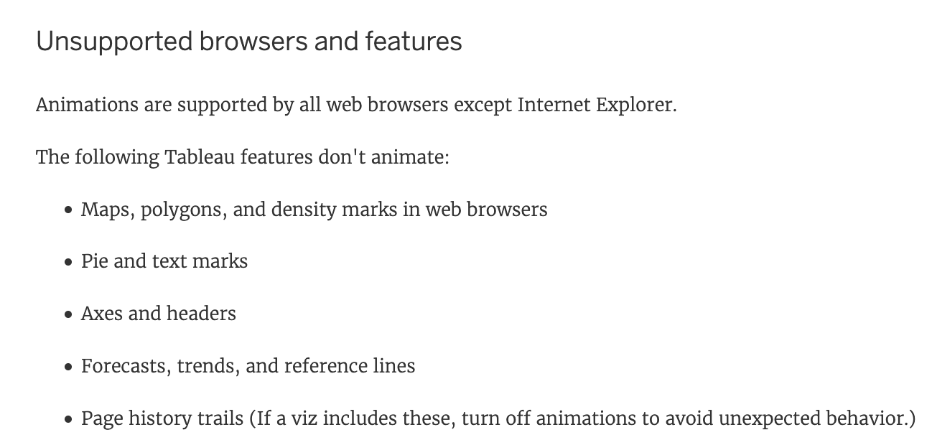

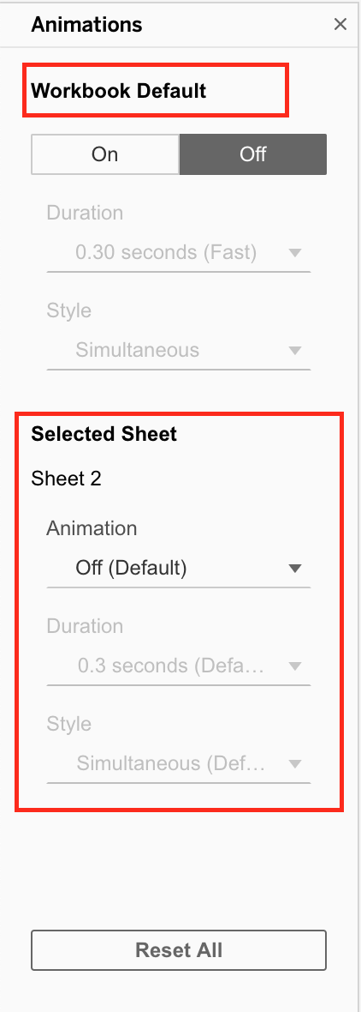

**As seen above, we can either turn the animations for the entire workbook (upper red box), or only for the current sheet ( lower red box )**

**1) Simultaneous animations**

The default simultaneous animations are faster and work well when showing value changes in simpler charts and dashboards.





**2) Sequential animations**

Sequential animations take more time but make complex changes clearer by presenting them step-by-step.



**Reference:** <https://help.tableau.com/current/pro/desktop/en-us/formatting_animations.htm>

Bottom of Form

Top of Form

Question 35:

**Skipped**

**For a relative date filter, the default anchor is _________________**

* 

**Today's date**

**(Correct)**

* 

**The current time**

* 

**The target date**

* 

**The date we specify**

**Explanation**

Relative date filters dynamically update to show a time period relative to when you open the view, such as the current week, the year to date, or the past 10 days. Relative date filters make it easy to create views that always show the most recent data.

**Step 1**: Drag a date field to the filter shelf

Right-click (control-click on Mac) and drag a date field from the Data window to the Filters shelf. In the Filter Field dialog box, click Relative Date, and then click Next.

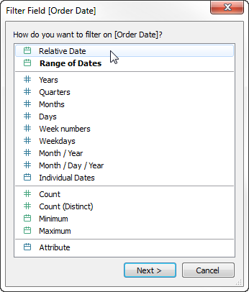

**Step 2:** Select a time unit

In the Filter dialog box, click Relative dates, and then select the unit of time for the filter. For example, to show only the three most recent weeks, select Weeks.

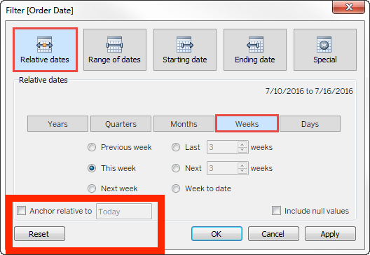

Here, you can clearly see that the **default date is TODAY**

**Reference:**<https://help.tableau.com/current/pro/desktop/en-us/qs_relative_dates.htm>

Bottom of Form

Top of Form

Question 36:

**Skipped**

**Which of the following is a good reason for using a bullet graph?**

* 

**Displaying the year-on-year growth in sales**

* 

**Comparing the actual sales against the target sales**

**(Correct)**

* 

**Forecasting future sales**

* 

**Analysing the trend over a given time period**

**Explanation**

A bullet graph is a variation of a bar graph developed to replace dashboard gauges and meters. A bullet graph is useful for comparing the performance of a primary measure to one or more other measures. Below is a single bullet graph showing **how actual sales compared to estimated sales**.

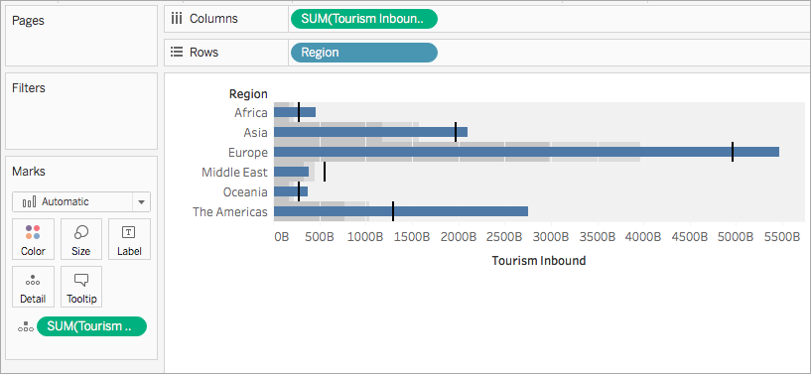

**Reference:**<https://help.tableau.com/current/pro/desktop/en-us/qs_bullet_graphs.htm>

Bottom of Form

Top of Form

Question 37:

**Skipped**

**True or False: Sets can be created on Measures**

* 

**True**

* 

**False**

**(Correct)**

**Explanation**

Sets are custom fields that are created within Tableau Desktop based on **dimensions** from your data source. They are subsets of your data, which can be created manually or computed. Either dimensions or measures can be used to determine **what is included or excluded** from a set using conditional logic, but to **CREATE** a set we use dimensions.

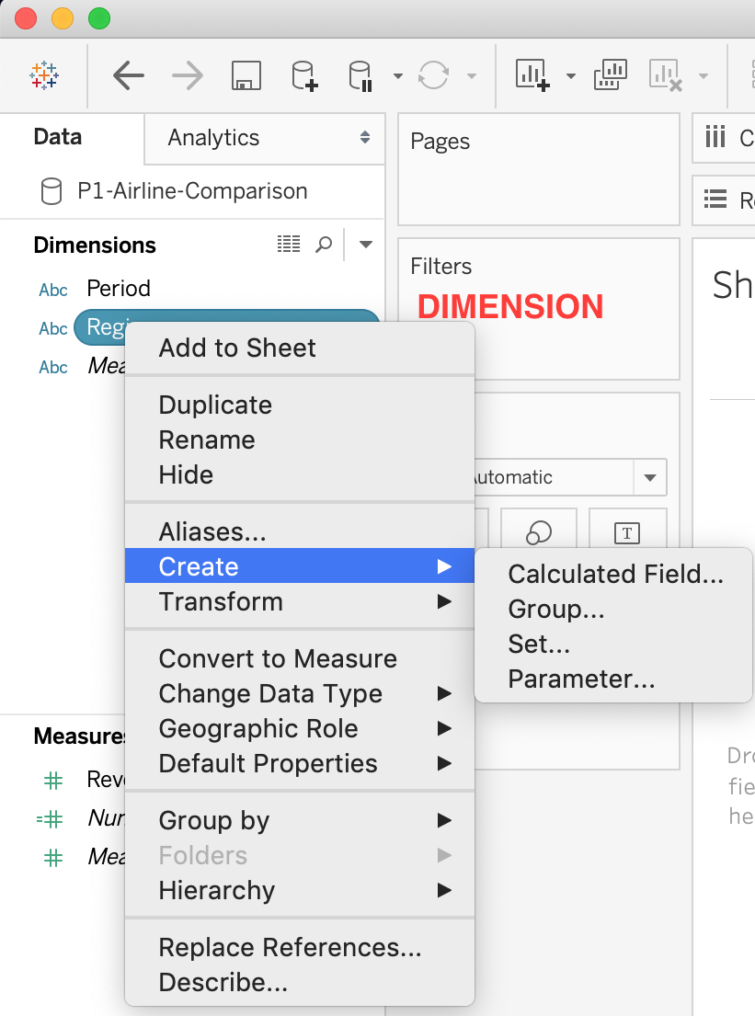

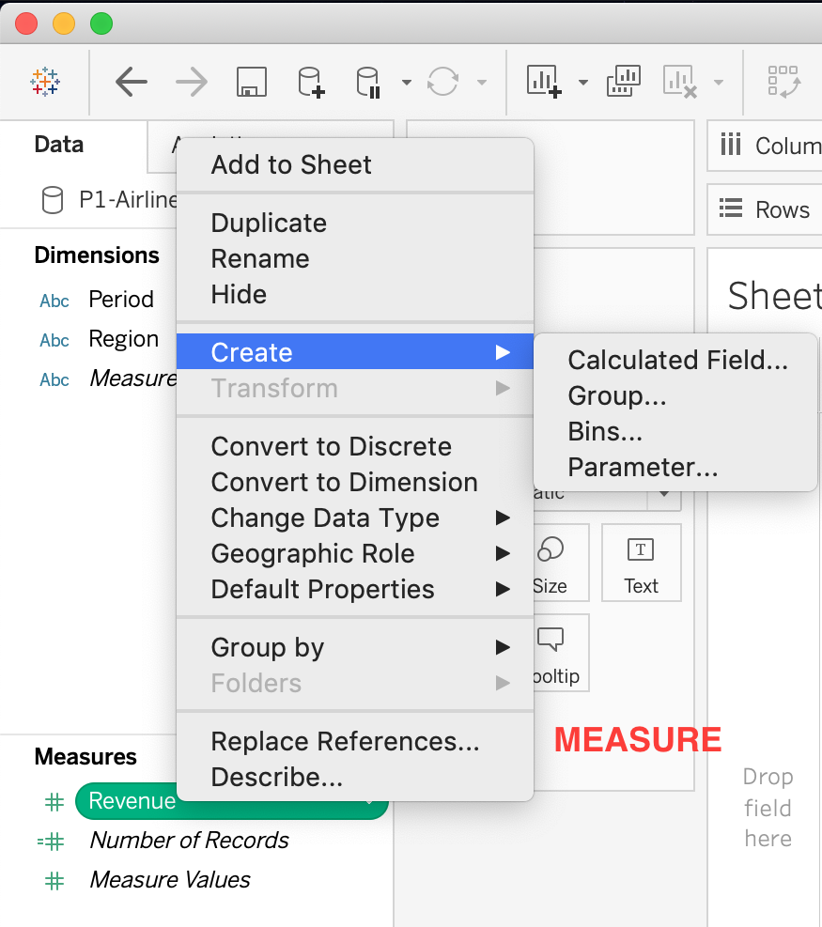

**Reference :**<https://interworks.com/blog/rcurtis/2016/10/26/tableau-deep-dive-sets-introduction-sets/>

Bottom of Form

Top of Form

Question 38:

**Skipped**

**How do you identify a continuous field in Tableau?**

* 

**It is preceded by a '=#' symbol in the data window**

* 

**It is preceded by a 'Abc' symbol in the data window**

* 

**It is identified by a blue pill in the visualization**

* 

**It is identified by a green pill in a visualization**

**(Correct)**

**Explanation**

When you connect to a new data source, Tableau assigns each field in the data source as dimension or measure in the Data pane, depending on the type of data the field contains. You use these fields to build views of your data.

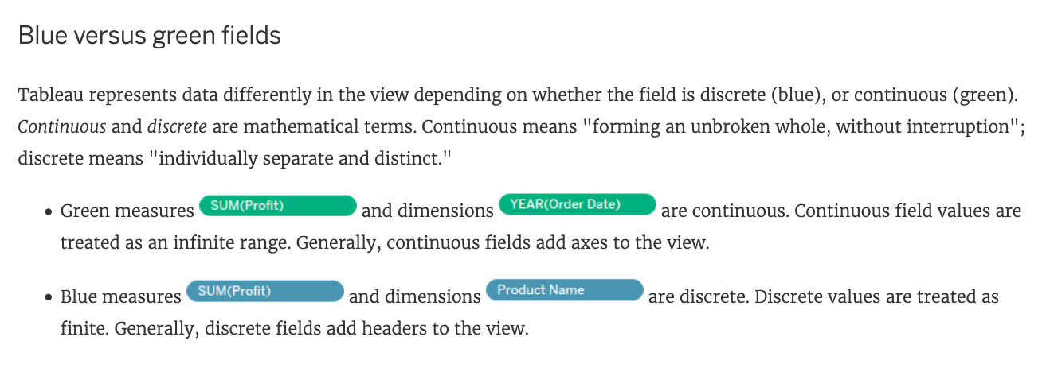

**Reference:**<https://help.tableau.com/current/pro/desktop/en-us/datafields_typesandroles.htm>

Bottom of Form

Top of Form

Question 39:

**Skipped**

**When you connect to a new data source, all worksheets that previously referred to the original data source now refer to the new data source. If the new data source does not have the same field names as the original workbook, the fields are marked with an exclamation point**



**. Which feature helps us fix this issue?**

* 

**Fix Metadata**

* 

**Aliases**

* 

**Replace References**

**(Correct)**

* 

**Renaming**

**Explanation**

**Replace References:**

When you successfully connect to a new data source, all worksheets in the workbook that previously referred to the original data source now refer to the new data source. If the new data source does not have the same field names as the original workbook, the fields become invalid and are marked with an exclamation point . You can quickly resolve the problem by replacing the field’s references.

For example, say you have a workbook connected to a data source that contains a Customer Name field. Then you edit the data source to point to a new data source that has all the same data but instead of Customer Name, the field name has been changed to Name. The Customer Name field remains in the Data pane but is marked as invalid. To make the field valid, you can replace the references, which means you can map the invalid field to a valid field in the new data source (for example, Customer Name corresponds to Name).

**Read more at**: <https://help.tableau.com/current/pro/desktop/en-us/howto_connect.htm>

Bottom of Form

Top of Form

Question 40:

**Skipped**

**The calculation [Ship Date] - [Order Date] will return _______________**

* 

**Number of orders placed in that duration**

* 

**Number of days between these dates**

**(Correct)**

* 

**Number of orders shipped between these dates**

* 

**Number of unique orders placed between these dates**

**Explanation**

As the names suggest, if we subtract the order date from the shipping date, we simply get the **number of days** between these 2 dates.

We can these use this calculated field in our charts, and can use COUNT, SUM, AVG etc with them according to our need.

Bottom of Form

Top of Form

Question 41:

**Skipped**

**How can you MANUALLY assign geographic roles to a dimension from the data pane?**

* 

**Edit the config file in My Documents -> MyTableauRepository for a quick fix**

* 

**Right click the dimension -> Geographic role -> and then assign the appropriate geographic role**

**(Correct)**

* 

**Right click the dimension -> Edit Default properties -> Assign geographic roles**

* 

**Edit the data source manually for a quick resolution**

**Explanation**

From the data pane, simply right click on the dimension, choose geographic role, and then select the appropriate role as follows:

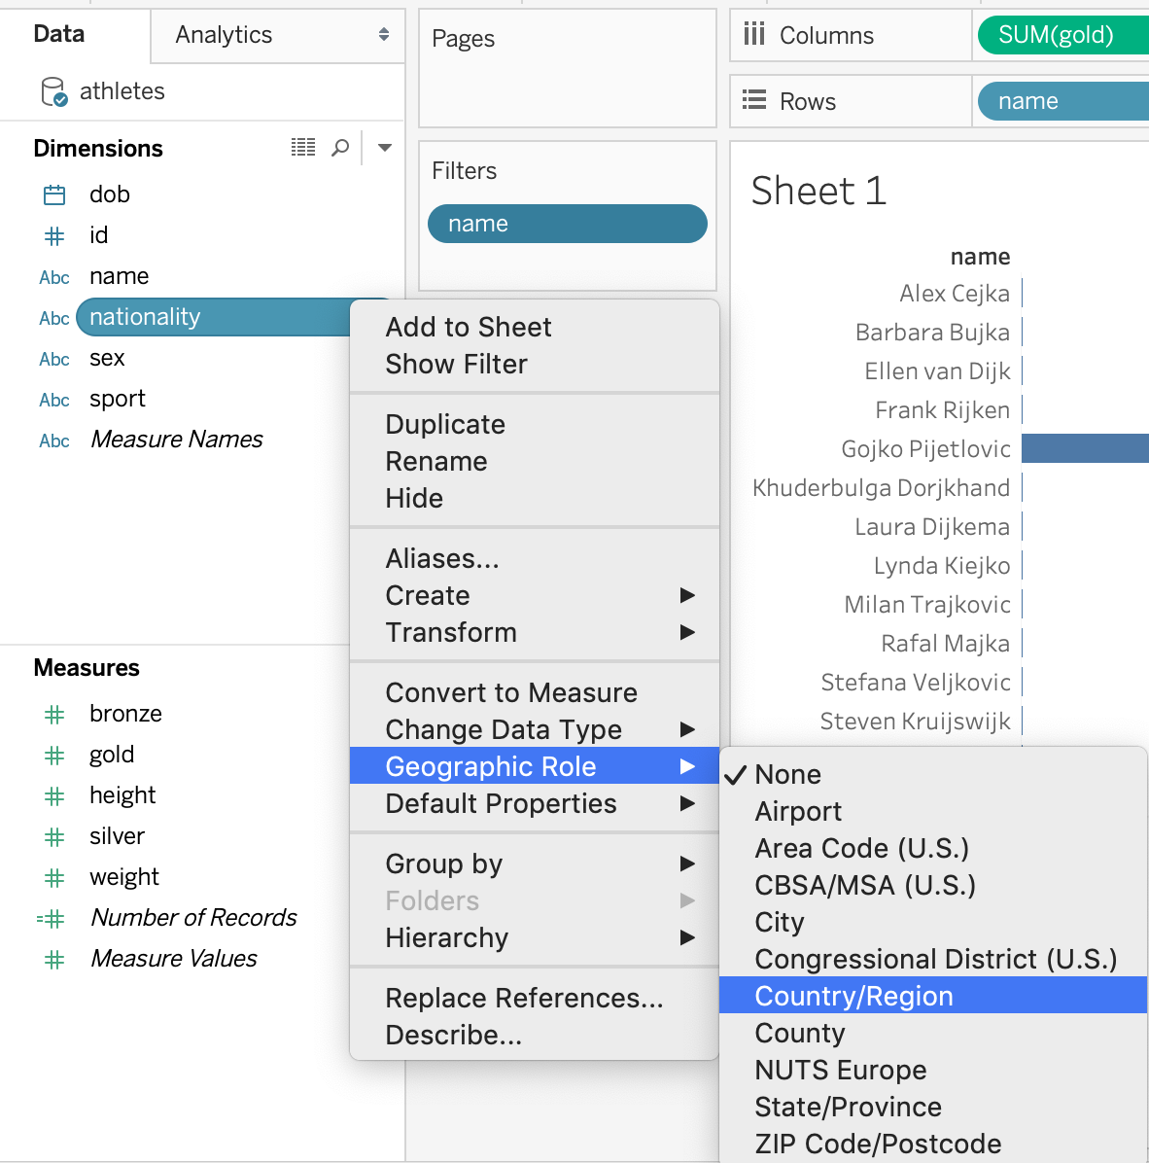

Bottom of Form

Top of Form

Question 42:

**Skipped**

**Dates in Tableau are typically treated as ______________**

* 

**Measures**

* 

**Dimensions**

**(Correct)**

**Explanation**

For relational data sources, dates and times are automatically placed in the **Dimensions** area of the Data pane and are identified by the date or date-time  icon. For example, the Order Date and Ship Date dimensions from an Excel data source are shown below:

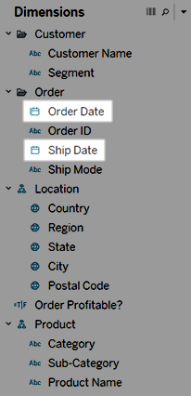

When you place a relational date on a shelf, the field name is automatically modified to reflect the **default date level.** Tableau defines the default date level to be the level at which there are multiple instances. For example, if the date field includes multiple years, the default level is year. However, if the date field contains data for just one year but includes multiple months, then the default level is month.

**Reference:**<https://help.tableau.com/current/pro/desktop/en-us/dates.htm>

Bottom of Form

Top of Form

Question 43:

**Skipped**

**Is it possible to deploy a URL action on a dashboard object to open a Web Page withinadashboardrather than opening the system’s web browser?**

* 

**YES, we can do this with the help of a Web-Page object**

**(Correct)**

* 

**YES, we can do this with the help of Tableau Public**

* 

**YES, we can do this with the help of a plugin**

* 

**NO, this is not currently possible in Tableau**

**Explanation**

**To interactively display information from the web INSIDE a dashboard, you can use a URL action with a web page object.**

For example, you might have a dashboard that shows profits by country. In addition to showing the profit data in your dashboard, you also want to display supplemental information about the countries from a web site.

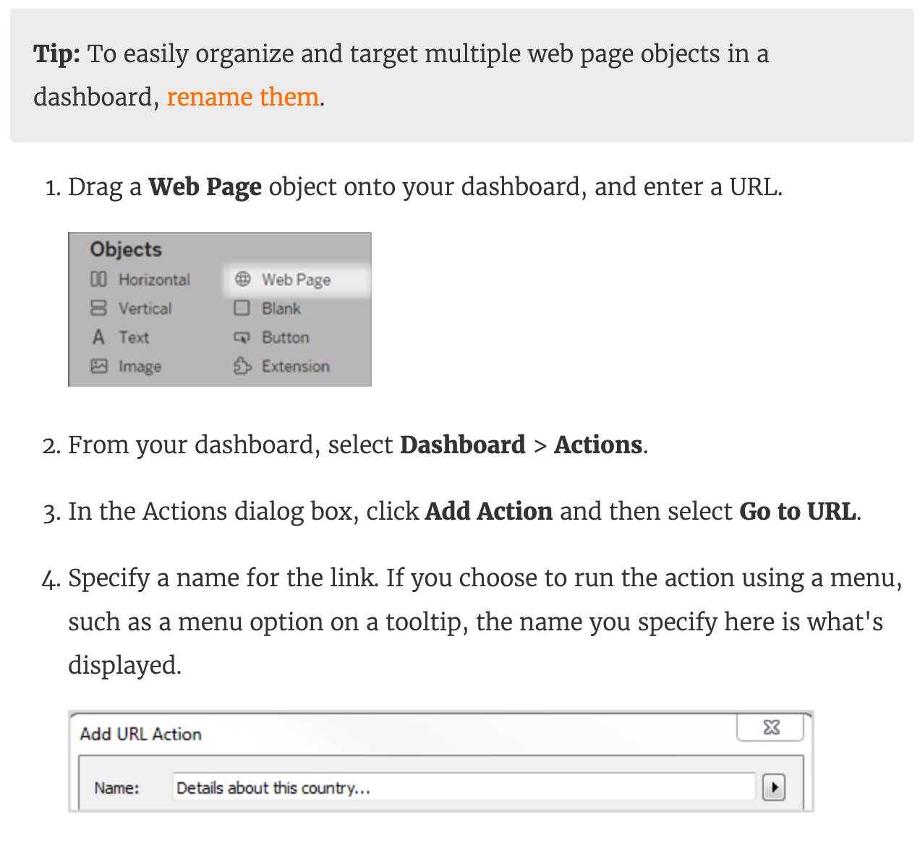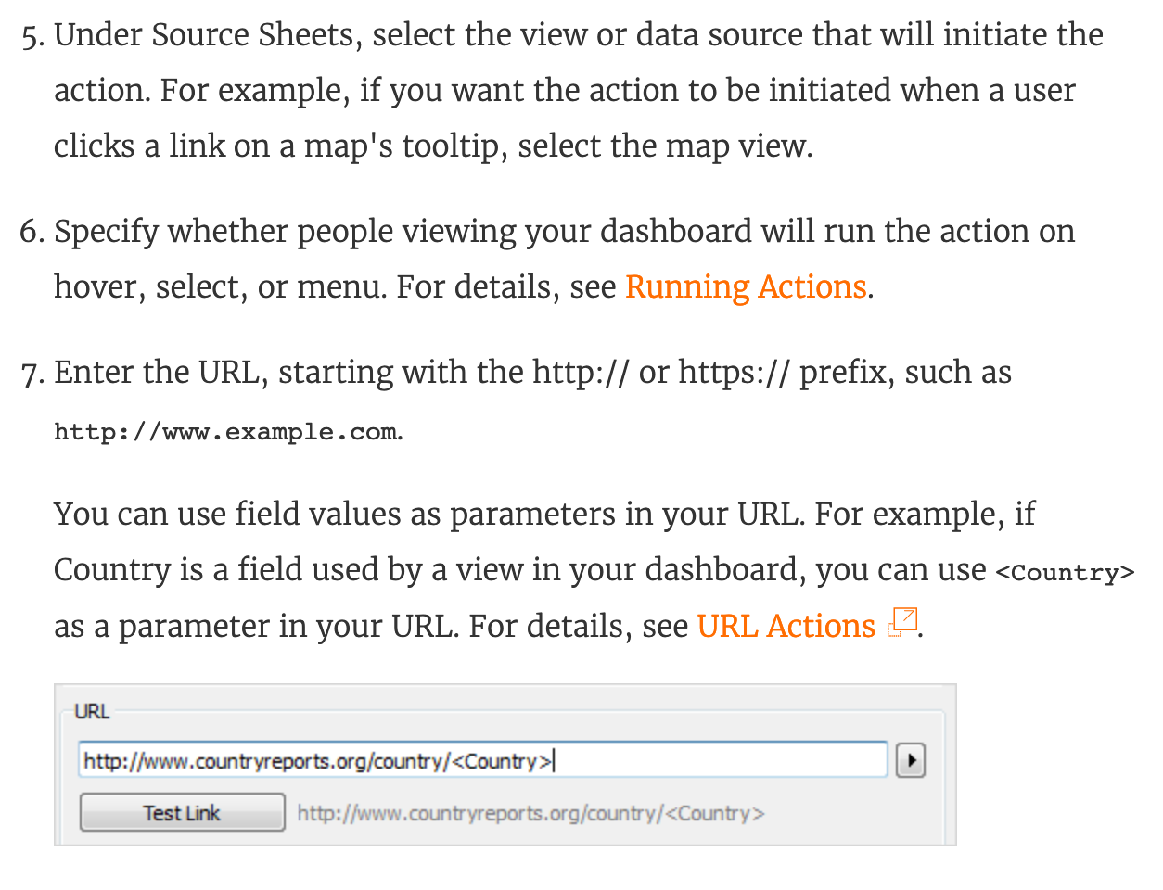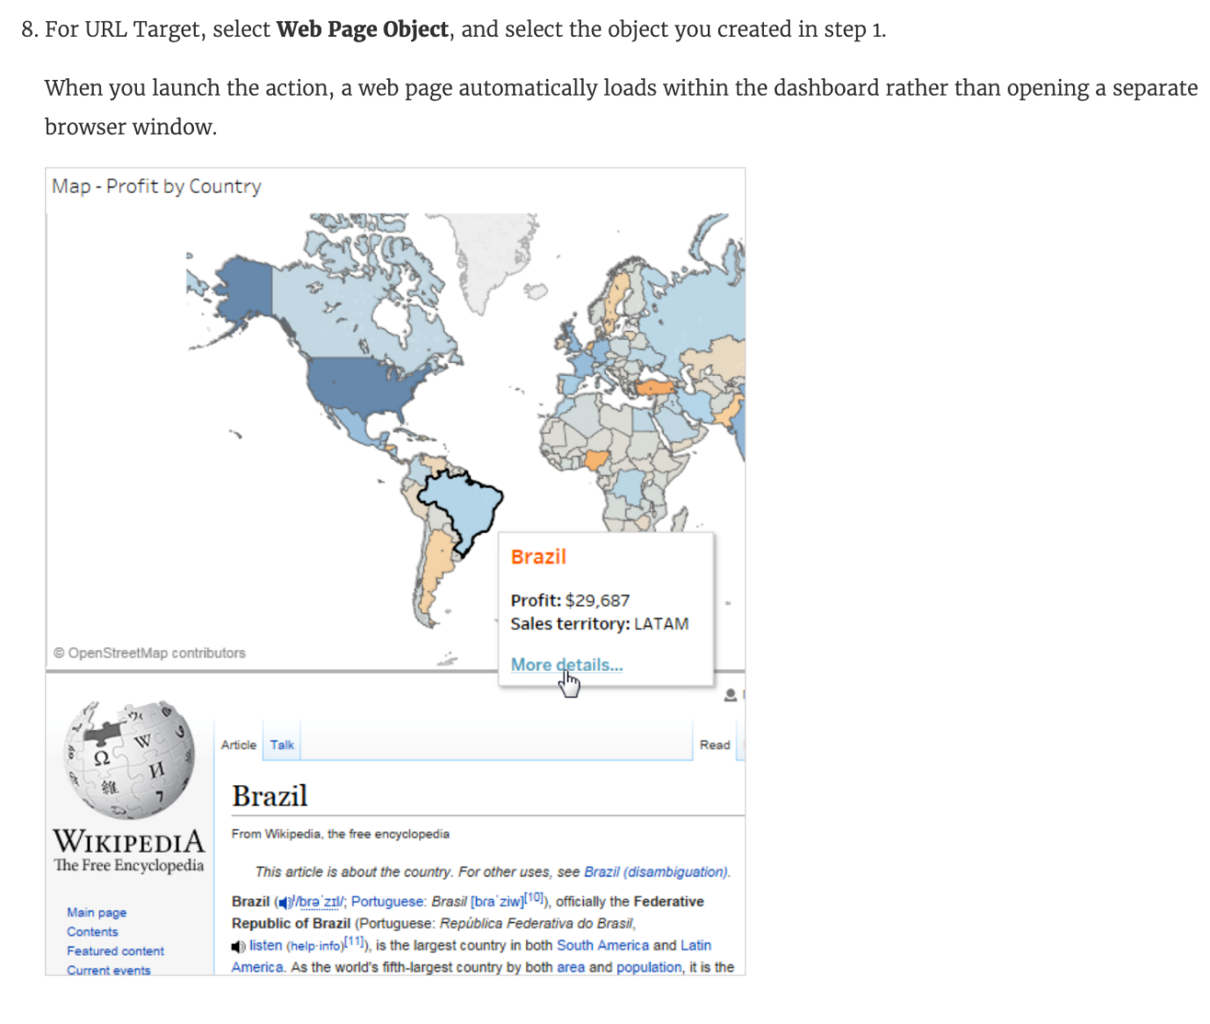

**Reference:**<https://help.tableau.com/current/pro/desktop/en-us/actions_dashboards.htm>

Bottom of Form

Top of Form

Question 44:

**Skipped**

**Which of the following are valid use-cases for the 'Manage Metadata' functionality?**

* 

**To see the table a field belongs to**

**(Correct)**

* 

**To see the field name in the original data source**

**(Correct)**

* 

**To clean and automatically fix the data issues in our data source**

* 

**To view all hidden fields**

**(Correct)**

**Explanation**

**To clean and automatically fix the data issues in our data source -**This is the definition of Data Interpreter.

**To rename the field in the original data source -**We never modify the original data source when managing metadata. All changes are local to Tableau for our convenience only.

All other options can be modified using the Manage Metadata property.

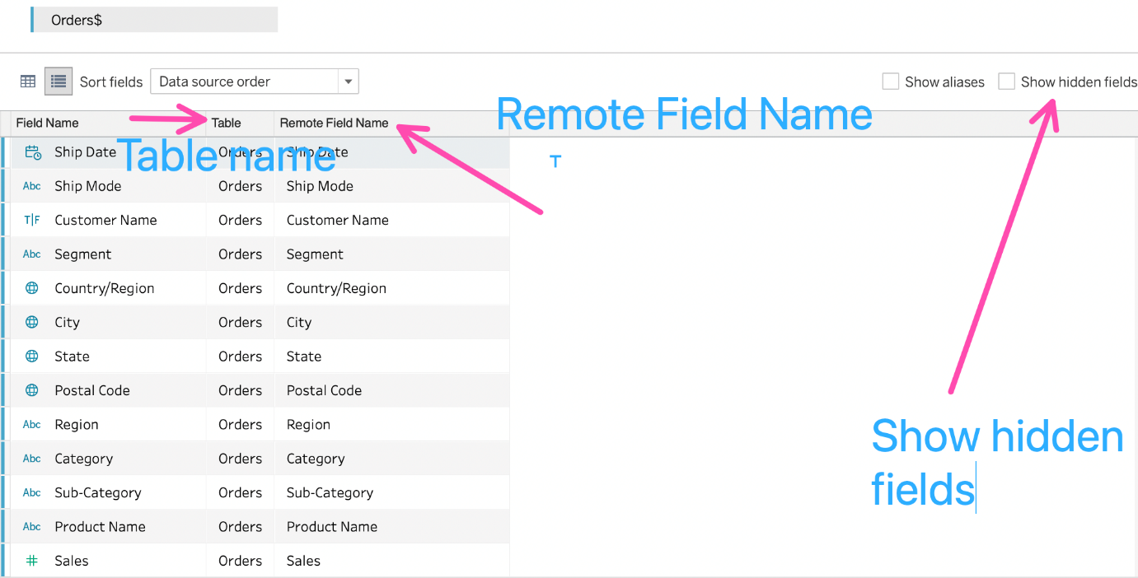

Bottom of Form

Top of Form

Question 45:

**Skipped**

**True or False: A reference line cannot be added from the Analytics Pane**

* 

**True**

* 

**False**

**(Correct)**

**Explanation**

You can add a reference line to any **continuous** axis in the view.

**To add a reference line:**

Drag Reference Line from the Analytics pane into the view. Tableau shows the possible destinations. The range of choices varies depending on the type of item and the current view.

In a simple case, the drop target area offers three options:

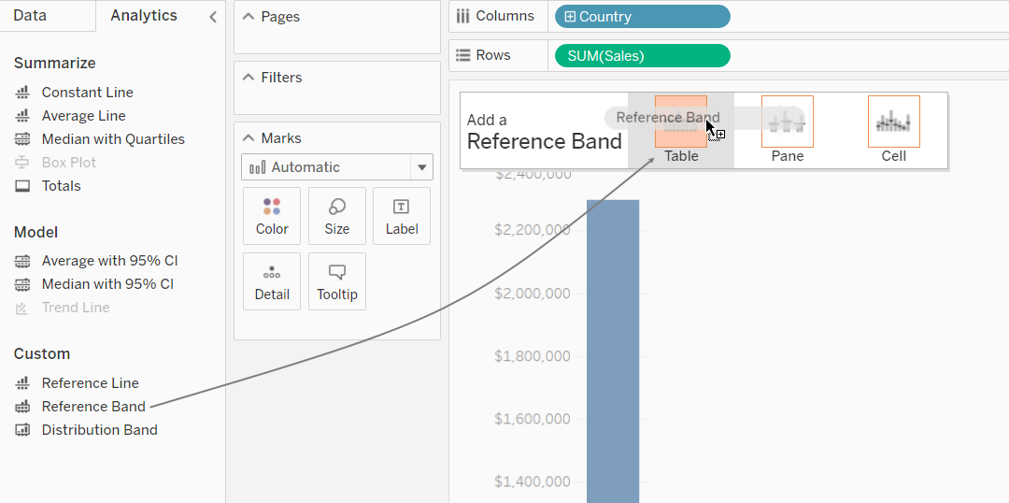

**Reference:**<https://help.tableau.com/current/pro/desktop/en-us/reference_lines.htm>

Bottom of Form